- KPI CALCULATIONS
- Total Revenue
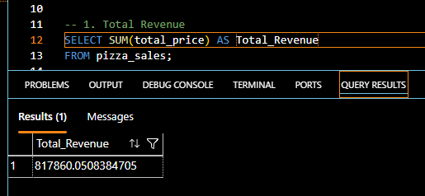

- Average order Value
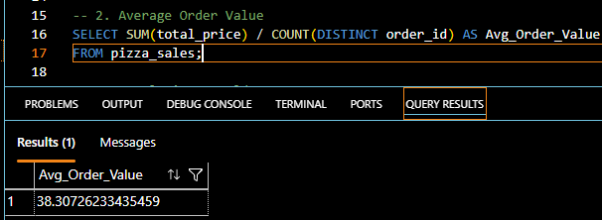

- Total Pizzas Sold
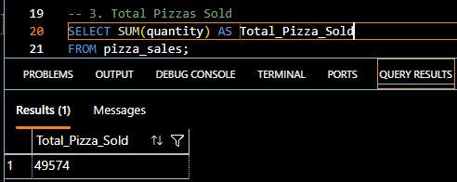

- Total Orders Placed
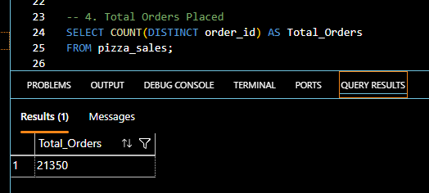

- Average Pizza per Order
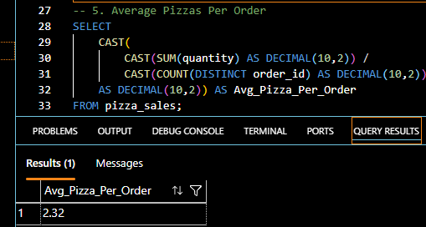

- CHART QUERIES

- Daily Trend for Total Orders:

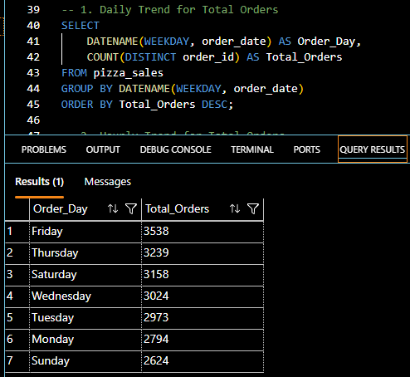

- Hourly Trend for Total Orders:
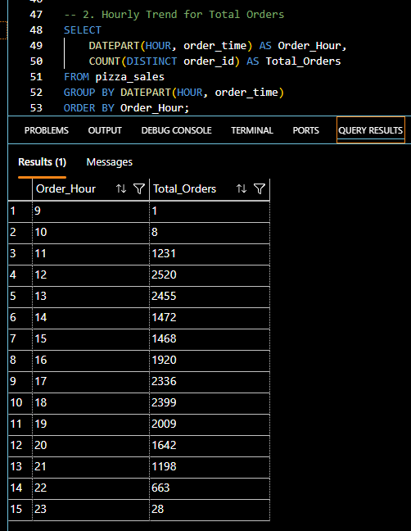
- Monthly Trend for Total Orders

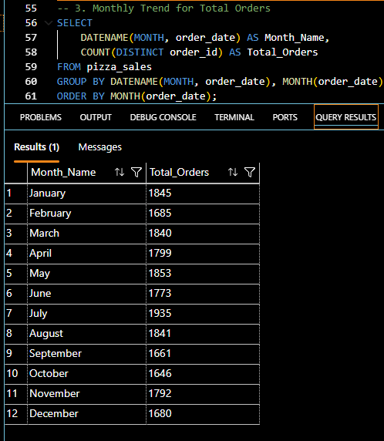

- Percentage of Sales by Pizza Category:

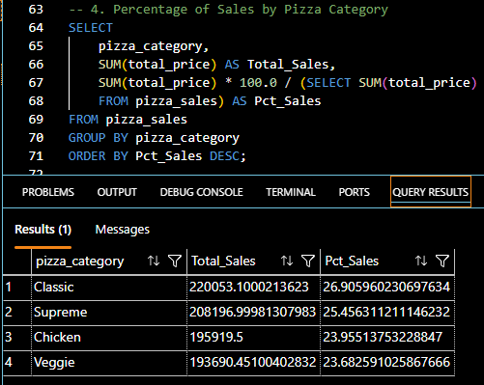

- Percentage of Sales by Pizza Size:

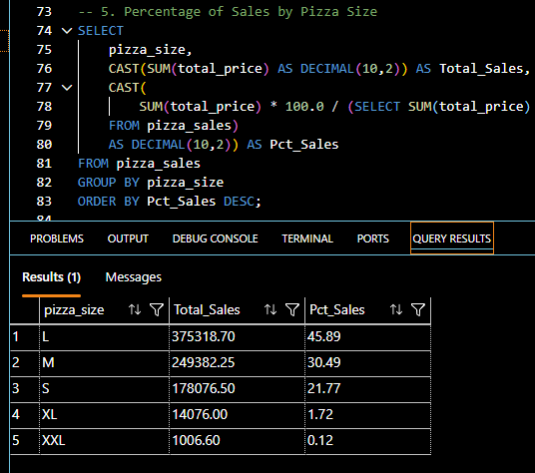

- Top 5 Best Sellers by Revenue:

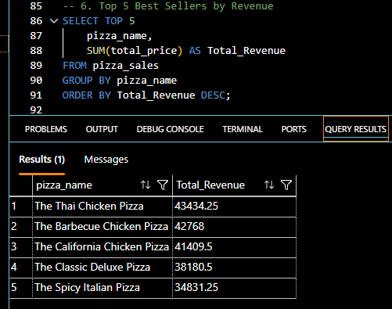
- Top 5 Best Sellers by Quantity:

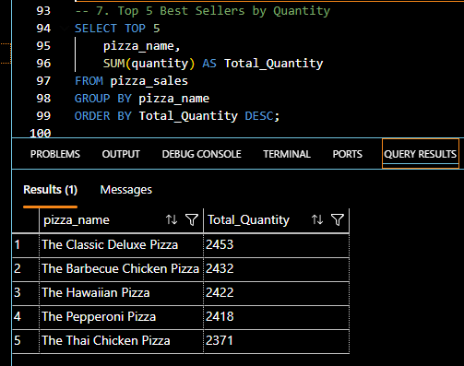

- Top 5 Best Sellers by Orders:

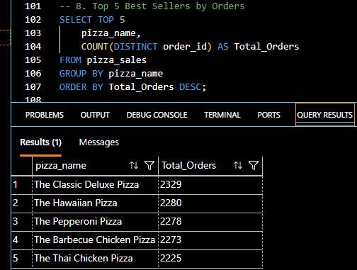
- Bottom 5 Best Sellers by Revenue:

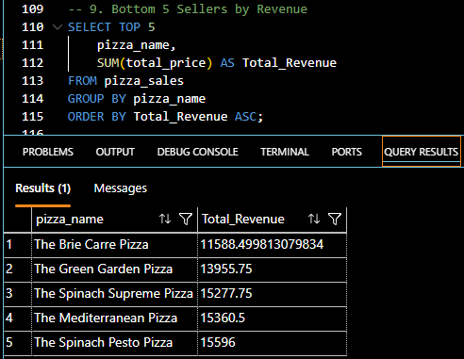

- Bottom 5 Best Sellers by Quantity:

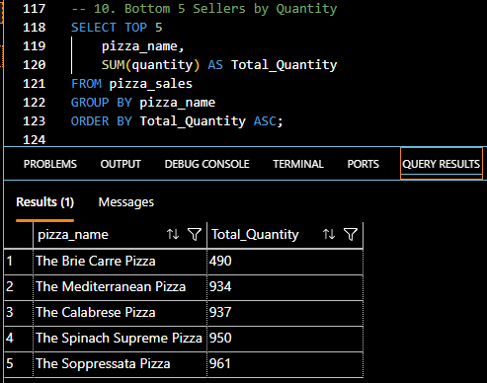

- Bottom 5 Best Sellers by Revenue:

